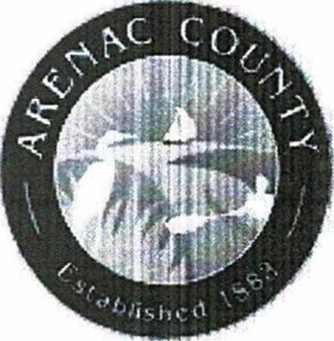
Arenac County Drain Commissioner
Steve Andrejewski 120 N. Grove St. - P.O. Box 747
Standish, Ml 48658 989-846-2011
THORNAPPLE DRAIN
NOTICE DAY OF REVIEW OF APPORTIONMENTS & DISTRICT BOUNDARIES
DATE: | Monday, April 27, 2026
TIME: | 9:00 a.m. to 5:00 p.m.
LOCATION: | Office of the Arenac County Drain Commissioner  120 N. Grove Street  Standish, Michigan 48658
QUESTIONS: | (989) 846-2011
The Office of the Arenac County Drain Commissioner will hold a Day of Review of Apportionments on the above date, time and location. The Day of Review is an opportunity to review the tentative apportionment of benefits for each parcel and municipality within the Thornapple Drainage District. A map of the Drainage District boundaries can be found on the Drain Commissioner's website at: https://arenaccountymi.gov/drain/.
The following is a list of any county, township, city, village to be assessed at large:
Arenac County Township of Turner
Township of Whitney at Large
Arenac County Road Commission
County ofArenac
At the Day of Review:
No appointment is necessary.
Staff members will be available to assist individuals and make revisions as necessary.
The computation of costs for the drain will be available.
Persons with disabilities needing accommodations for effective participation in the Day of Review should contact the Drain Commissioner's Office at the number noted above (voice) or through the Michigan Relay Center at 7-1-1 (TDD) at least 24 hours in advance of the Day of Review to request mobility, visual, hearing or other assistance.
Comments:
Comments on the apportionment of benefits may be submitted to the Drain Commissioner in writing before the date of the day of review by mail to:
Office ofthe Arenac County Drain Commissioner, 120 N. Grove St. — P.O. Box 747, Standish, MI
48658
Or by email to:
sandreiewski@arenaccountvmi.gov,
or comments may be submitted in writing or verbally at the day of review. Comments submitted in advance must be received by the Drain Commissioner prior to the day of review to ensure consideration.
Assessments & Appeal:
Drain assessments are collected in the same manner as property taxes and will appear on your winter tax bill. If drain assessments are being collected for more than one (1) year, you may pay the assessment in full with any interest to date at any time and avoid further interest charges.
You may appeal the Drain Commissioner's determination of apportionments to the Arenac County Probate Court within ten (10) days after the day of review.
